Create an Annual Report Portal for an Academic Institute

**Ms. Kamble S.S.1, Ms. Lohar A.K.2,Ms. Dukare V.S.3, Ms. Kulkarni S.R.4**

Guides: 1.Prof. Hosale A.P.

Department of Computer Engineering

A.G.Patil Institute Of Technology Solapur, India

**Abstract**

**Processes associated with undergraduate final year projects have always been a manual process which requires a lot of paperwork and could sometimes be a cumbersome and tiring task for the personnel in charge. The manual process sometimes leads to time wasting [3]. To address these challenges, the "Annual Report Portal for Educational Institutions" has been developed as a comprehensive web-based solution to simplify and automate the reporting process. This portal provides a structured framework tailored to three primary user roles: Admin, Faculty, and Student. Admin users are empowered to manage users, approve submissions, set deadlines, and generate detailed, professional-quality reports [1]. The traditional process of generating annual reports in educational institutions is often time-consuming, paper-based, and error-prone. To streamline and modernize this process, we propose the development of a comprehensive, web-based Annual Report Portal tailored to the needs of academic institutes. This portal is structured around three user roles: Admin, Faculty, and Student. Admin users can manage user access, approve submissions, set deadlines, and generate detailed reports. To further enhance the utility of the portal, an interactive dashboard was developed using Microsoft Power BI. This dashboard integrates academic, co-curricular, and research performance indicators, offering real-time visual insights. Key features include dynamic filters by academic year and department, drill-down capabilities, and cross-report interactions. Metrics covered include CGPA and SGPA distribution, extracurricular participation, student achievements, and research outputs such as publications and workshops. By fostering transparency and data-driven decision-making, the system improves efficiency and supports continuous institutional development.**

**Keywords: Annual Report Portal, Dashboard, Educational Institutions, Admin, Faculty, Key metrics.**

**I. Introduction**

In today’s rapidly evolving educational landscape, the generation of annual reports stands as a critical process for institutions. These reports serve as a comprehensive record of an institution's academic achievements, research advancements, student activities, alumni contributions, and future goals. They not only reflect the institution's progress but also play a key role in strategic planning and stakeholder communication. However, the traditional methods of preparing these reports, which often involve manual data collection, review, and compilation from various departments, are riddled with challenges such as inefficiency, human errors, data inconsistencies, and a lack of centralized control. These issues become even more pronounced in institutions managing large volumes of diverse data, highlighting the urgent need for an efficient and automated solution.[1]

In modern academic environments, annual reports are vital for recording an institution’s achievements, research activities, student engagement, alumni contributions, and strategic goals. Despite their importance, the creation of these reports often relies on manual methods, including spreadsheets, email, and word processors. This manual process introduces challenges such as data redundancy, inconsistencies, and lack of standardization, particularly in large institutions handling diverse data.

To address these challenges, our project introduces a digital solution—a Power BI-based Annual Report Dashboard that automates report generation and provides insightful visual analytics. The system not only simplifies the reporting process but also enhances institutional transparency and accountability. Through interactive dashboards, academic leaders can identify performance trends, evaluate participation levels, and make informed decisions that improve academic outcomes.

Moreover, this initiative supports the broader goal of digital transformation in education by reducing reliance on paper and enabling data centralization. Future enhancements may include integration with student information systems, predictive analytics, and expanded stakeholder access. This paper outlines the design, development, and implementation of this system, demonstrating how business intelligence tools can revolutionize institutional reporting.

**II. Literature Review**

1. Transparency and Accountability: Annual report portals enhance transparency by providing easy access to institutional data (Kumar, 2020).[6]

2. Stakeholder Engagement: Portals facilitate communication between institutions, stakeholders, and the public (Singh, 2019). [6]

3. Institutional Performance: Annual reports help assess institutional effectiveness and identify areas for improvement (Rai, 2018). [6]

4. Data-Driven Decision-Making: Portals provide valuable insights for data-driven decision-making (Sharma, 2020).[6]

5. Technological Advancements: Modern portals leverage technology to improve reporting efficiency and accessibility (Jain, 2019). [6]

*A. Future Directions*

1. AI & Analytics: Incorporating machine learning for predictive insights and early academic interventions.

2. Mobile Optimization: Ensuring dashboard access across smartphones and tablets for wider usability.

3. Personalized Reports: Tailoring dashboards for different users like students, faculty, and admin.

4. Real-Time Reporting: Enabling live updates on CGPA, attendance, and academic records.

5. Collaborative Platforms: Integrating with tools like MS Teams to promote cross-department collaboration.

6. Alumni & Placement Insights: Linking academic performance with placement outcomes for better career planning.

7. Automated Alerts: Generating warnings or commendations based on academic thresholds.

8. Gamification: Using badges and leaderboards to boost engagement and performance.

*B. References*

Jain, A. (2019). Designing an Annual Report Portal for Educational Institutions. Journal of Educational Technology Development and Exchange.[6]

Kumar, P. (2020). Annual Report Portal for Educational Institutions: A Framework for Effective Communication. Journal of Education and Human Development.[6]

Rai, A. (2018). Analyzing the Effectiveness of Annual Report Portals in Educational Institutions. International Journal of Educational Management. [6]

Sharma, R. (2020). Developing an Integrated Annual Report System for Higher Education Institutions. International Journal of Information and Communication Technology Education.[6]

Singh, V. (2019). Annual Report Portal for Educational Institutions: A Comparative Study. Journal of Educational Technology and Society.[6]

**III. TECHNOLOGIES USED**

*A. Excel*

Excel is a widely-used spreadsheet application from Microsoft, utilized in this project for collecting and organizing raw data from various departments. Its tabular structure and built-in functions make it ideal for managing student performance records, attendance logs, and activity participation. Excel’s flexibility allows academic staff to easily input, update, and share data without requiring advanced technical skills. In this project, Excel served as the initial data source, later integrated into the portal through preprocessing scripts. Its compatibility with CSV and other formats ensured smooth transition into the system's backend for further processing and visualization.

*B. PowerBI*Power BI is a powerful business analytics tool developed by Microsoft that enables interactive data visualization and reporting. In this project, Power BI was used to generate insightful dashboards and visual summaries of academic and departmental data. Its drag-and-drop interface and support for real-time data connections make it user-friendly for non-technical users while providing advanced analytical capabilities. Power BI’s ability to import data from Excel, SQL databases, and web APIs allowed seamless integration with existing records. The platform’s visualizations helped in identifying trends, performance gaps, and departmental achievements, enhancing decision-making for administrators and stakeholders.[4]

*C. HTML*HTML (HyperText Markup Language) is the foundational language used to structure content on the web. In this project, HTML was used to design and organize the frontend layout of the Annual Report Portal. It provided the structural framework for creating user interfaces, including forms, tables, navigation bars, and content sections. HTML's compatibility with CSS and JavaScript allowed for the creation of responsive and interactive web pages. Its semantic elements also contributed to better accessibility and maintainability of the portal. As a core web technology, HTML ensured that the portal was both user-friendly and easily accessible across devices and browsers.

*D. CSS*CSS (Cascading Style Sheets) is a styling language used to define the visual presentation of HTML elements. In this project, CSS was used to enhance the user interface of the Annual Report Portal by applying consistent layouts, colors, fonts, and responsive design principles. Through the use of classes and IDs, CSS enabled the customization of individual components such as buttons, forms, and tables, improving overall user experience. Media queries were employed to ensure compatibility across various screen sizes and devices. By separating style from structure, CSS contributed to a clean and maintainable frontend design.

*E. JavaScript*JavaScript is a dynamic scripting language used to add interactivity and functionality to web pages. In this project, JavaScript played a crucial role in enhancing the frontend of the Annual Report Portal by enabling features such as form validation, dynamic content updates, and interactive charts. It allowed seamless communication between the user interface and backend APIs through asynchronous requests (AJAX), improving the responsiveness of the portal. JavaScript was also used in conjunction with libraries like Chart.js to create visual representations of data, aiding in better user understanding. Its versatility and widespread browser support made it an essential component of the portal’s user experience.

**IV. Results**

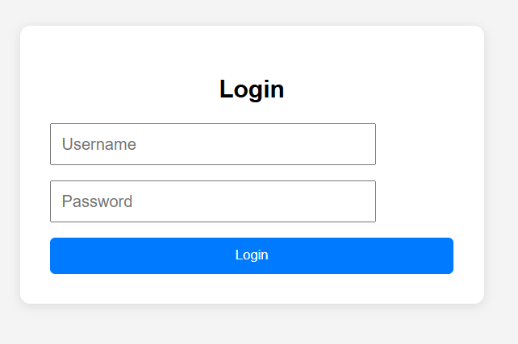

The developed Annual Report Portal effectively consolidates and visualizes academic data from multiple departments, including Computer Science, Mechanical, Electrical, Civil, and General Science. Upon successful login, users are presented with an intuitive dashboard that allows filtering by year and department, enhancing user accessibility and experience.

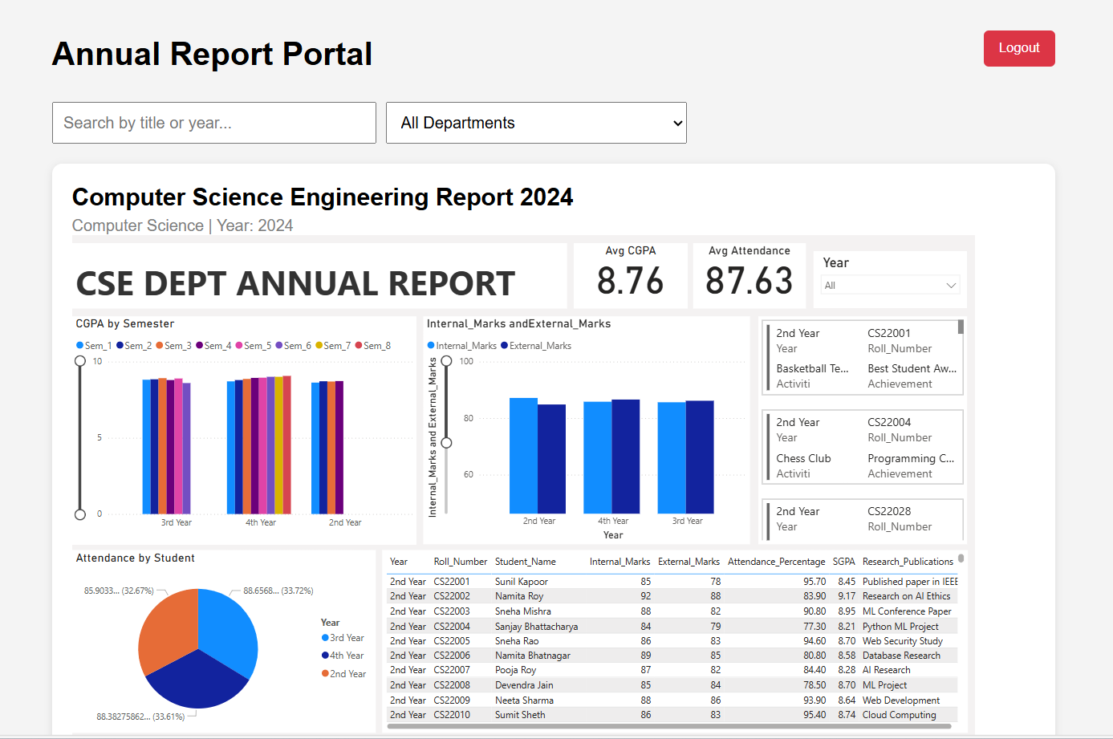

Each departmental report is displayed using interactive dashboards powered by **Microsoft Power BI**, embedded directly within the portal. These dashboards provide detailed insights into CGPA distribution by semester, internal and external marks comparison, attendance patterns, and individual student performance. Key performance metrics like average CGPA and attendance are prominently displayed, enabling quick comparative analysis.

The visual reports also highlight student achievements and research publications, which are dynamically retrieved and shown alongside academic data. The use of bar graphs, pie charts, and tables provides an easy-to-understand representation of complex data, supporting data-driven decision-making by faculty and administrators.

This unified system demonstrates a scalable model for institutions to monitor performance trends, recognize student excellence, and enhance transparency in academic reporting

**V. System Design and Architecture**

Architecture: The architecture of the Annual Report Dashboard is designed to ensure a streamlined and scalable flow of data from its source to interactive visualization. It integrates multiple components—ranging from data acquisition to transformation, modeling, and reporting—ensuring that academic and extracurricular records are processed efficiently and visualized meaningfully for stakeholders.

**System Design for Multi-Department Academic Analytics Dashboard**

**1. System Overview**

This dashboard presents a comprehensive academic performance and participation report across five engineering departments:

* Civil
* CSE (Computer Science)
* Electrical
* Mechanical
* General Science

It supports comparative analysis on CGPA, attendance, internal/external marks, student achievements, and research publications.

**2. Architecture Overview**

A. Data Source Layer

* Excel Workbooks / CSV Files: Each department provides semester-wise datasets.
* SQL Server / Dataverse (optional): For scalable storage and real-time updates.

B. ETL & Data Preparation

* Power Query in Power BI handles:
  + Data import for each department.
  + Cleaning: null handling, duplicate removal, type conversions.
  + Transformation: standardizing column names across departments.

C. Data Model

Each department has its own dataset with the following structure:

|  |  |
| --- | --- |
| Column Name | Description |
| Roll_Number | Unique student ID |
| Student_Name | Full name |
| Department | Civil, CSE, Electrical, etc. |
| Year | Academic year (1st,2nd, 3rd, 4th) |
| Internal_Marks | Internal exam scores |
| External_Marks | University exam scores |
| SGPA | Semester GPA |
| Attendance_Percentage | Total attendance in % |
| Research_Publications | Paper or project titles |
| Activities/Achievements | Competition/Club participation |

* Relationships:
  + Common fields (e.g., Roll_Number, Year, Department) allow unified analysis.

**3. Visualization Layer**

Key Visuals

* Department Selector: Allows filtering all visuals by department.
* KPI Cards: Shows overall average CGPA and Attendance.
* Charts:
  + CGPA by Semester: Clustered by semester and academic year.

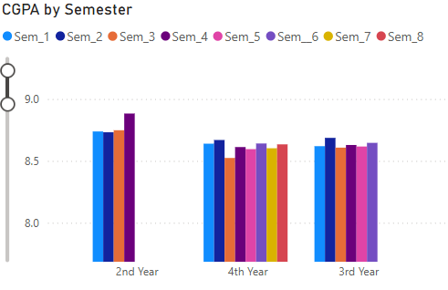

* + Internal vs External Marks: Comparison bar chart.

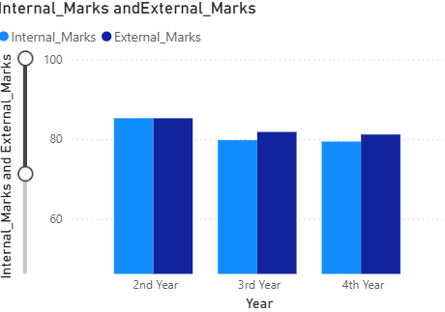

* + Attendance by Student: Donut chart segmented by year.

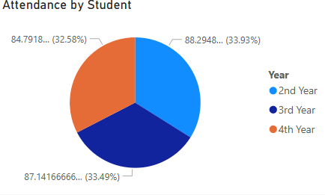

* Detailed Table: Roll Number, Name, Marks, SGPA, Attendance, Publications.

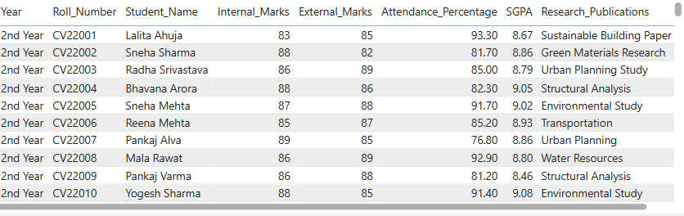

* Achievement Cards: Highlights student activities by department/year.

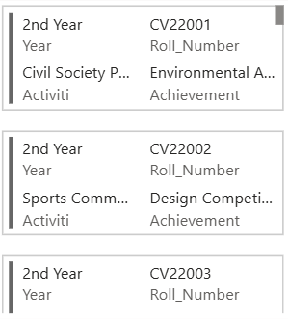

**4. DAX & Metrics**

Example Calculations:

DAX

CopyEdit

Avg_CGPA = AVERAGE(StudentData[SGPA])

Avg_Attendance = AVERAGE(StudentData[Attendance_Percentage])

Conditional formatting can be applied based on department or year to highlight low performance or exceptional scores.

**5. Interactivity & Filtering**

* Slicers: Department, Year
* Drill-throughs: From summary to student-level details
* Cross-filtering: Dynamic interconnection between visuals
* Bookmarks/Pages: Each department (Civil, CSE, etc.) has its own tab/page

**6. Deployment & Sharing**

* Published to Power BI Service
* Embedded in internal portals or shared as PDFs
* Access restricted to faculty/admins per department

**REFERENCES**

1. Nivedha S1, Akarshana S2, Geo Jeevan Raj C3, Gopika A S4, Gowtham S T5, Manoj Kumar M6, Mohamed Irsath M7(2024). Annual Report Portal for Educational Institutions International Journal of All Research Education and Scientific Methods (IJARESM)
2. Duckett, J. (2011). HTML and CSS: Design and Build Websites. Wiley.
3. 1Abdulkareem Ademola, 2Adeyinka Adewale, 3Dike U. Ike (2013) Design and Development of a University Portal for the Management of Final Year Undergraduate Projects International Journal Of Engineering And Computer Science ISSN:2319-7242
4. Microsoft Power BI Wikipedia, the free encyclopedia(June 2023)
5. "Developing an Integrated Annual Report System for Higher Education Institutions" (2019) - International Journal of Information and Communication Technology Education (IJICTE).
6. ANNUAL REPORT PORTAL FOR EDUCATIONAL INSTITUTES (Department of computer science) Dr. Amita Jain [1], Vedika Chaurasiya [2], Sanidhya Rathore [3], Shivam Patel [4], Sumit Pandey [5] Kamlesh Gupta [6], Vinay Panchal [7]